**Assignment 09**

**KD1-Indrajeet-86641**

Q1. Write a query that lists each order number followed by the name of the customer who made the order.

🡺 **select onum, cname from orders, customers where orders.cnum = customers.cnum;**

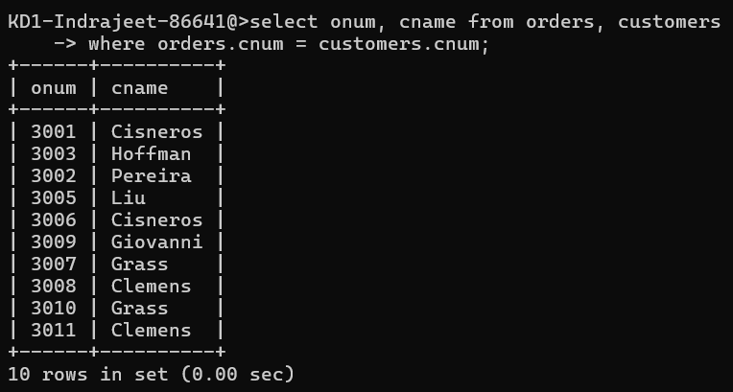

Q2. Write a query that gives the names of both the salesperson and the customer for each order along with the order number.

🡺 **select onum, sname, cname from orders, salespeople, customers where salespeople.snum = customers.snum and customers.cnum = orders.cnum;**

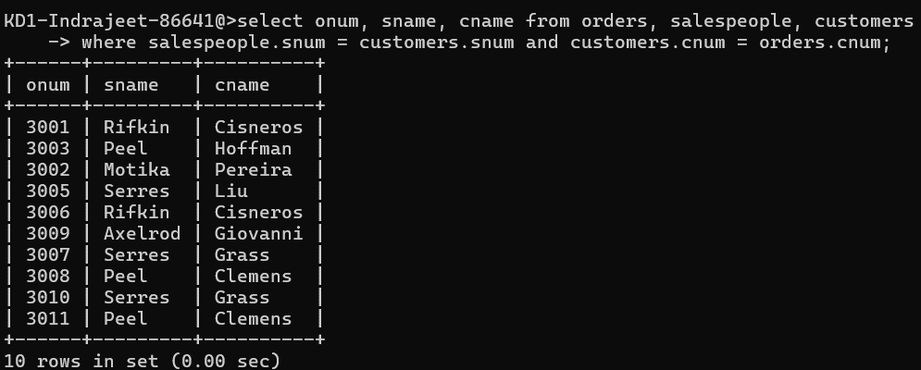

Q3. Write a query that produces all customers serviced by salespeople with a commission above 12%. Output the customer’s name, the salesperson’s name, and the salesperson’s rate of commission..

🡺 **select cnum, sname, comm from customers, salespeople**

**where comm > 0.12 and salespeople.snum = customers.snum;**

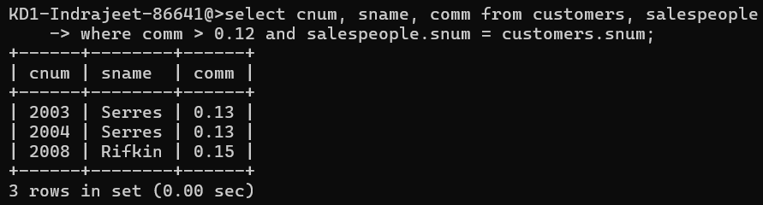

Q4. Write a query that calculates the amount of the salesperson’s commission on each order by a customer with a rating above 100.

🡺 **select onum, amt * comm, rating**

**from orders, customers, salespeople**

**where rating > 100 and orders.cnum = customers.cnum**

**and salespeople.snum = orders.snum order by 1;**

